1.
A Project Report On

GAS CYLINDER AGENCY

Submitted in partial fulfillment of the requirement for the BCA Semester-4 Python Programming Subject Final Examination.
BACHELOROFCOMPUTER APPLICATIONS
(B.C.A.)

Academic Year 2025 – 26

Bansi Vaishnani - (9240052102)

Internal Guide
Prof. Amit Gohel



Rajkot-Morbi Road, At & PO : Gauridad, Rajkot 360 003. Gujarat. India.

CONTENTS

Chapters | Particulars | Page No.
1 | SYNOPSIS | 3
2 | PREAMBLE | 3
2.1 | General Introduction
2.2 | Statement of Problem
2.3 | Objective and Scope of the Study
2.4 | Module Description with functionality
3 | SYSTEM DESIGN AND DEVELOPMENT | 5
3.1 | Data Flow Diagram (DFD)
3.2 | Table Structure
3.3 | Menu Design
3.4 | Screen Design (Screen shots with short description)
4 | CONCLUSION | 14
5 | LEARNING DURING PROJECT WORK | 14
6 | BIBLIOGRAPHY | 14
6.1 | Online References
6.2 | Offline References

1. SYNOPSIS
The Gas Cylinder Agency Control Panel is a desktop application developed using Python programming language with the help of Tkinter GUI and JSON file handling.
This system is designed to manage gas cylinder bookings, customer information, and stock efficiently. It reduces manual work and improves accuracy in managing records.
The system includes the following features:
- Customer Management
- Gas Booking System
- Billing with GST Calculation
- Stock Management
- Data Visualization using Graphs and Charts

2. PREAMBLE

2.1 General Introduction
This project aims to automate the manual system used in gas agencies. Traditional systems involve paperwork and manual calculations which are time-consuming and error-prone.
This application provides a simple and user-friendly interface to manage customers, bookings, and stock.
The technologies used in this project are:
- Tkinter for Graphical User Interface (GUI)
- JSON for data storage
- Matplotlib for graphical representation

2.2 Statement of Problem
The manual gas agency system faces several problems such as:
- Improper data management
- Time-consuming billing process
- Difficulty in tracking stock
- Lack of proper reporting and analysis

2.3 Objective and Scope

Objectives:
- To automate the gas booking process
- To manage customer data efficiently
- To generate billing receipts with GST
- To visualize sales data using graphs

Scope:
- Suitable for small-scale gas agencies
- Can be extended using database systems like MySQL
- Can be upgraded to web or mobile applications

2.4 Module Description

1. Customer Module
- Add new customer
- View customer details
- Update customer information
- Delete customer

2. Booking Module
- Book gas cylinders
- Generate receipt with GST
- Store booking history

3. Stock Module
- Display available gas cylinders

4. Search Module
- Search booking using Booking ID

5. Graph Module
- Bar Graph showing number of bookings per customer
- Pie Chart showing sales distribution

3. SYSTEM DESIGN AND DEVELOPMENT

3.1 Data Flow Diagram (DFD)
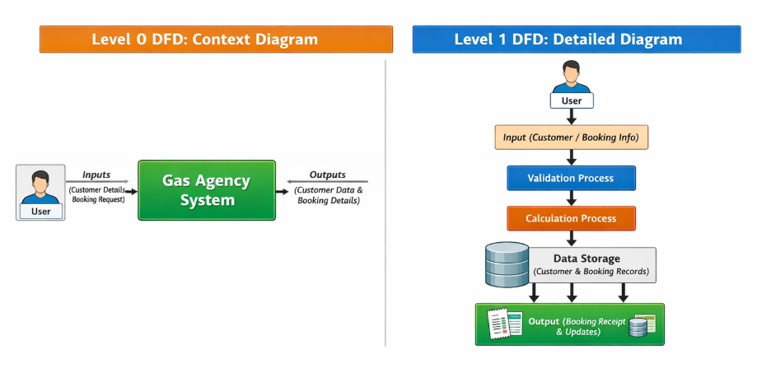

3.2 Table Structure

Customer Table

Field | Type
Customer ID | String
Name | String
Address | String
Mobile | String

Booking Table

Field | Type
Booking ID | Integer
Name | String
Mobile | String
Quantity | Integer
Total | Float
GST | Float
Final Amount | Float
Date-Time | String

Stock Table

Field | Type
Available Cylinders | Integer

3.3 Menu Design

Main Menu Options:
- Add Customer
- View Customers
- Book Gas
- Check Stock
- View Bookings
- Search Booking
- Delete Customer
- Update Customer
- Booking Graph
- Sales Pie Chart
- Exit

3.4 Screen Design

3.4.1 Dashboard Screen

The main menu contains all options in the form of buttons.
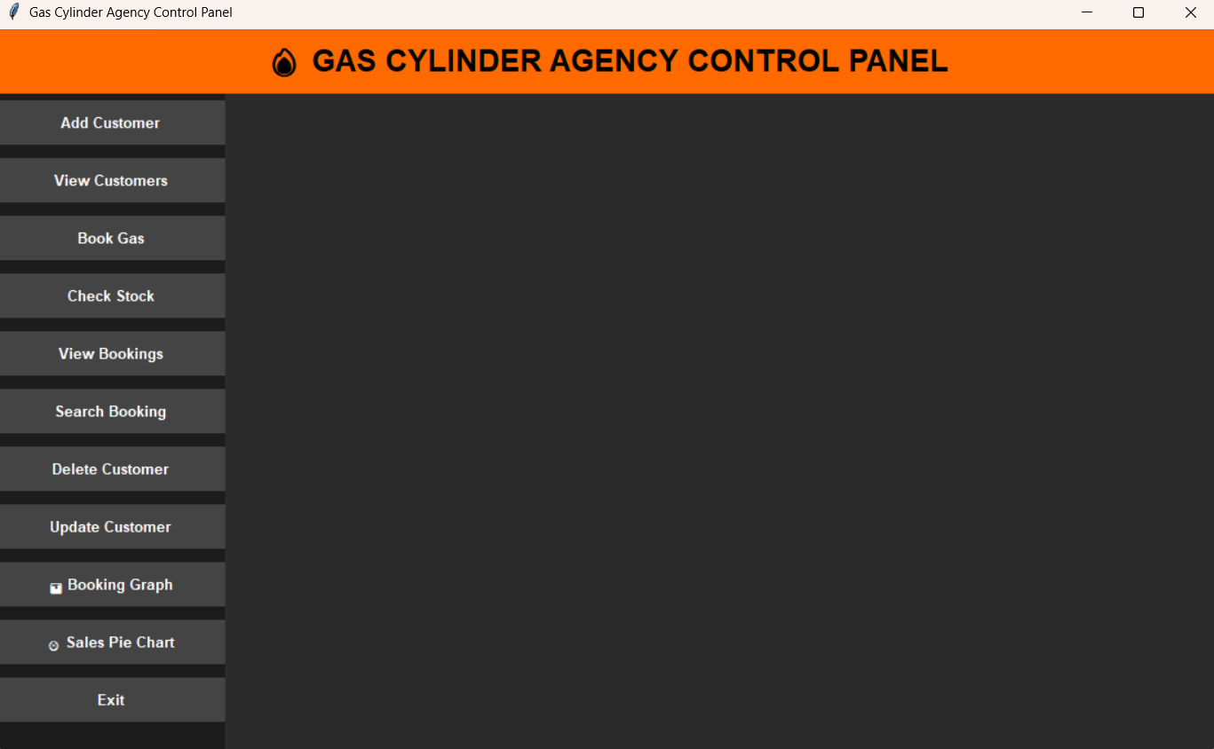
    - Add Customer
This screen is used to enter customer details.
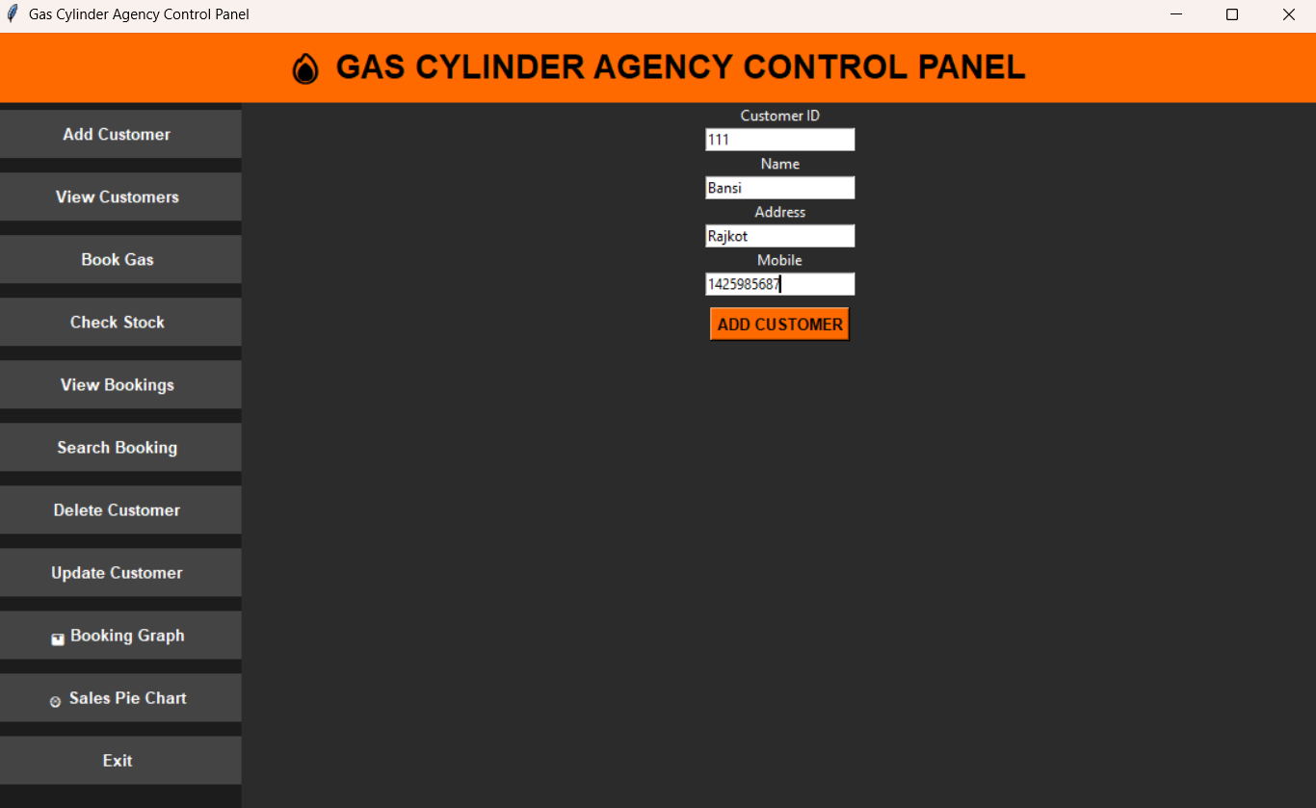
    - View Customers
All Customers are displayed in a list format.
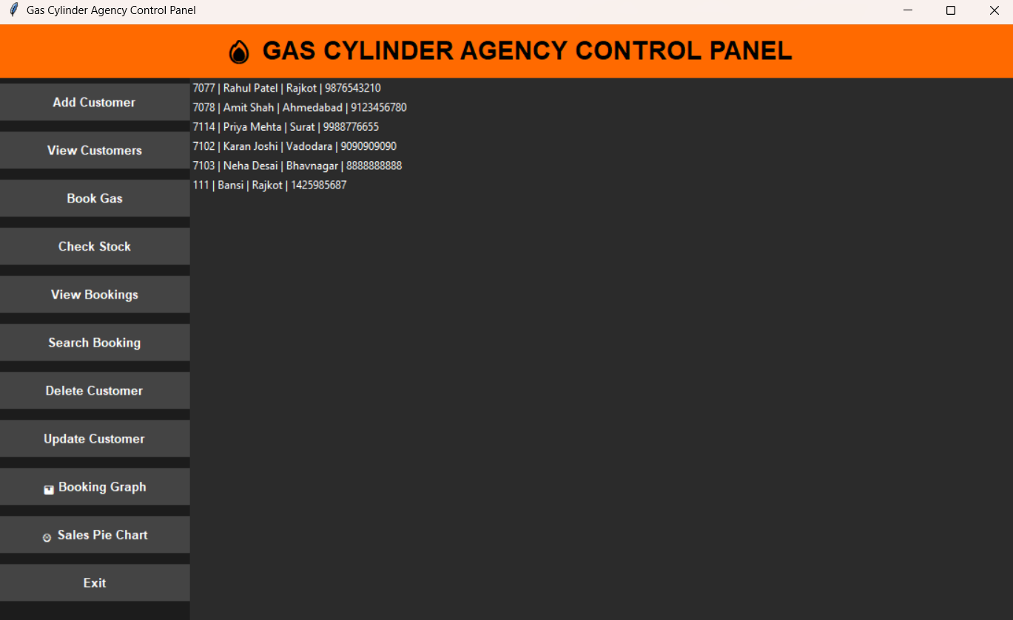
    - Book Gas
The Book Gas module is used to book gas cylinders for customers.
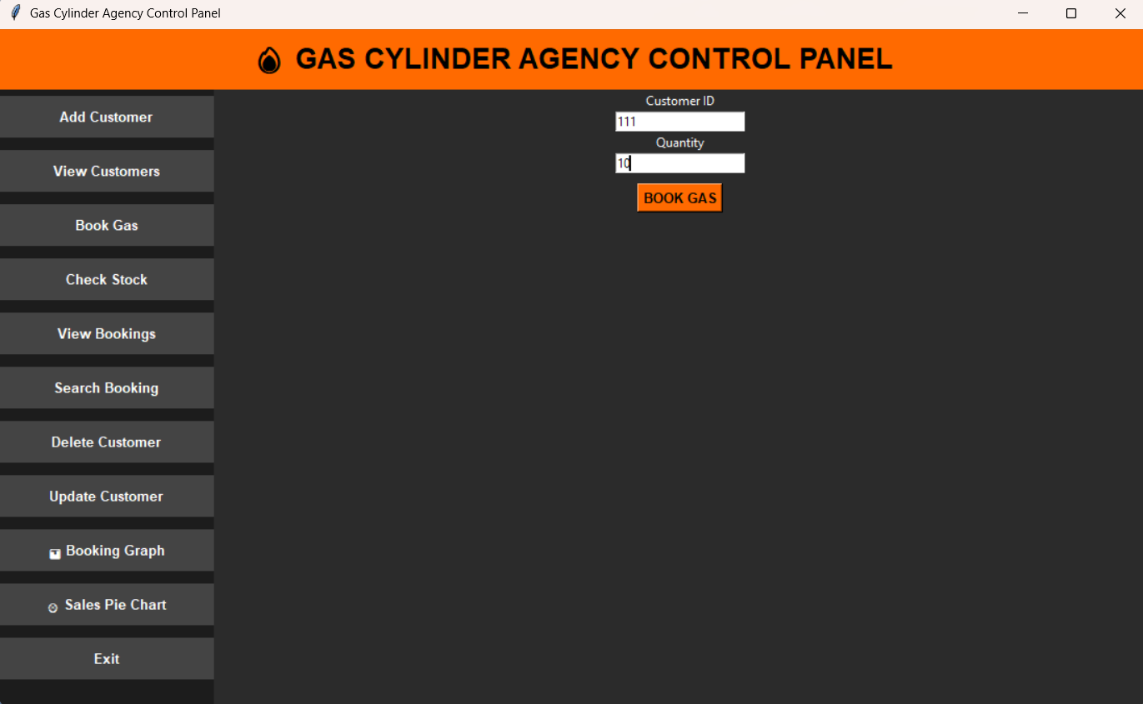
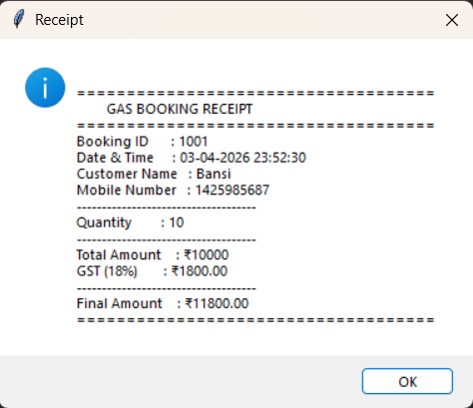

    - Check Stock
The Check Stock module is used to check the available gas cylinder stock.
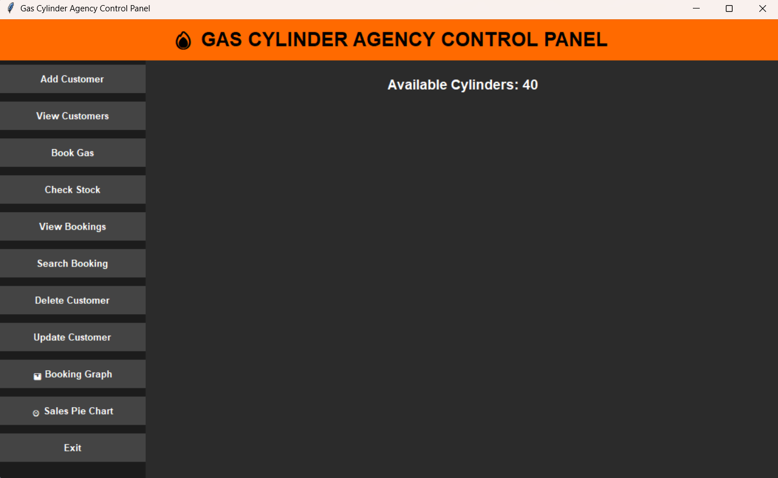
    - View Bookings
The View Bookings module is used to check all booking records.
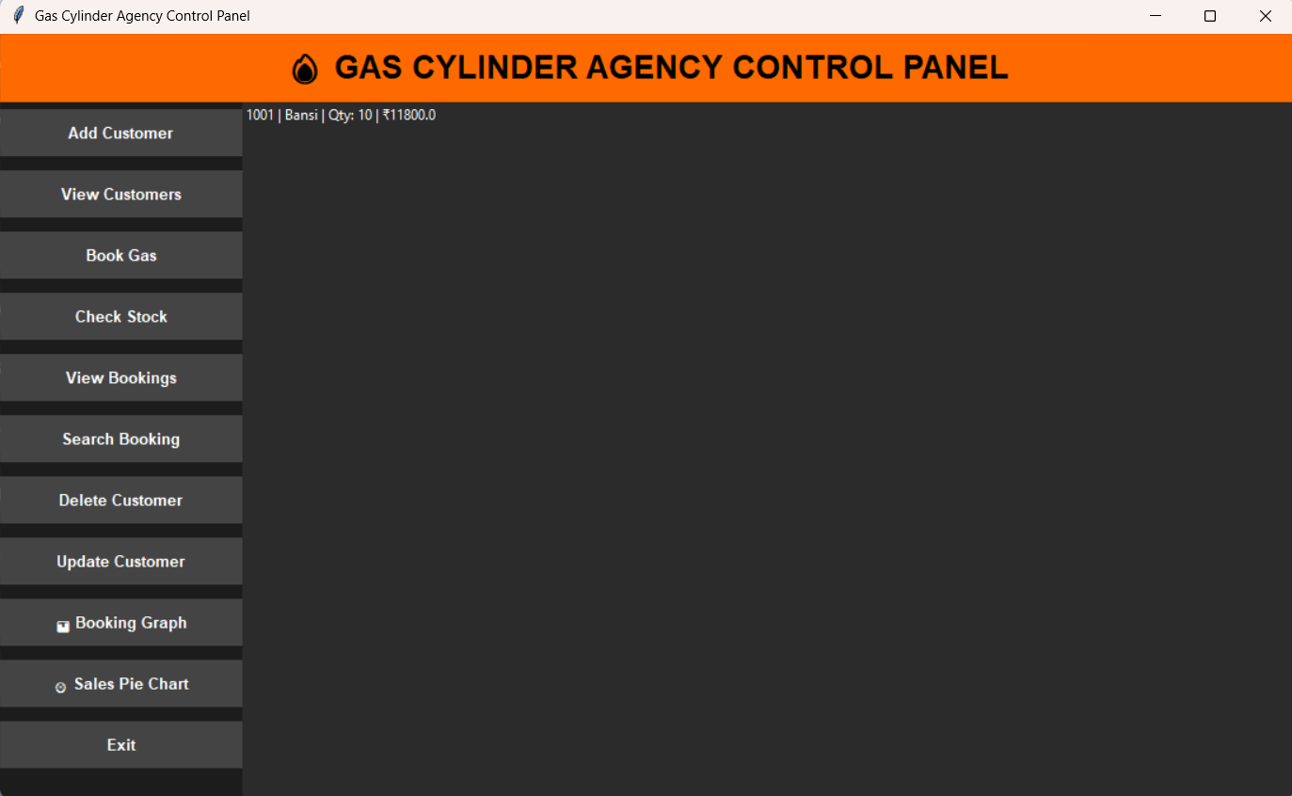
    - Search Booking
The Search Booking module is used to check a specific booking.
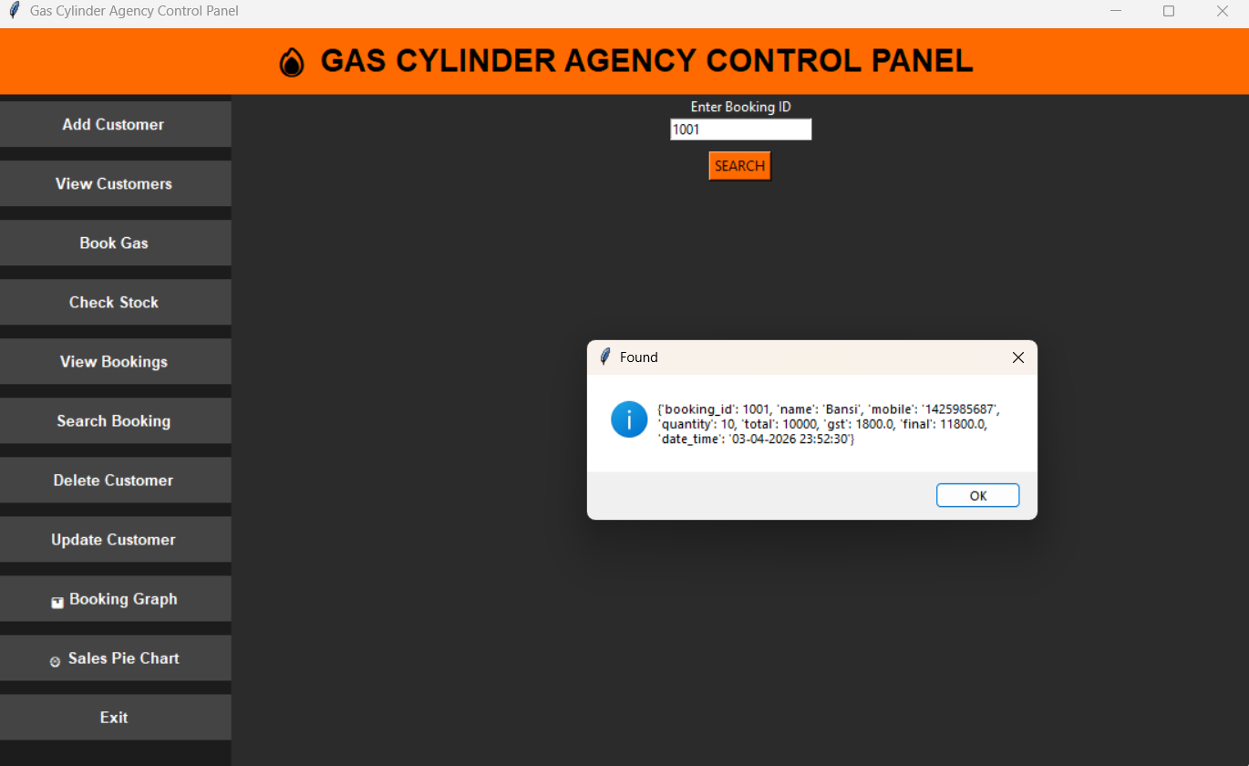
    - Delete Customer
The Delete Customer module is used to delete customer records.
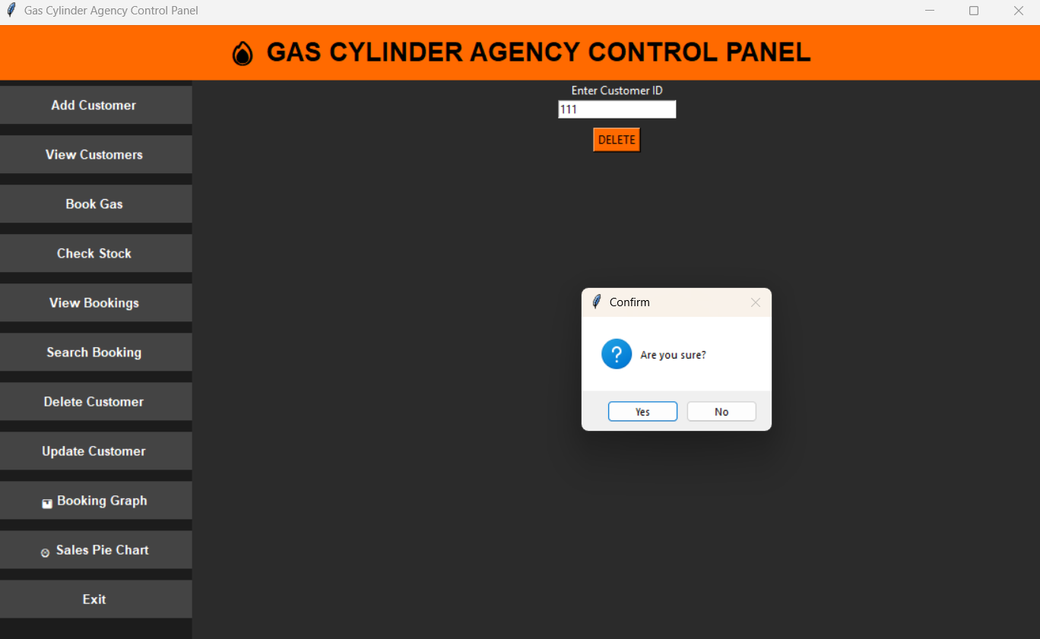
    - Update Customer
The Update Customer module is used to update the customer's name, address, and mobile number.
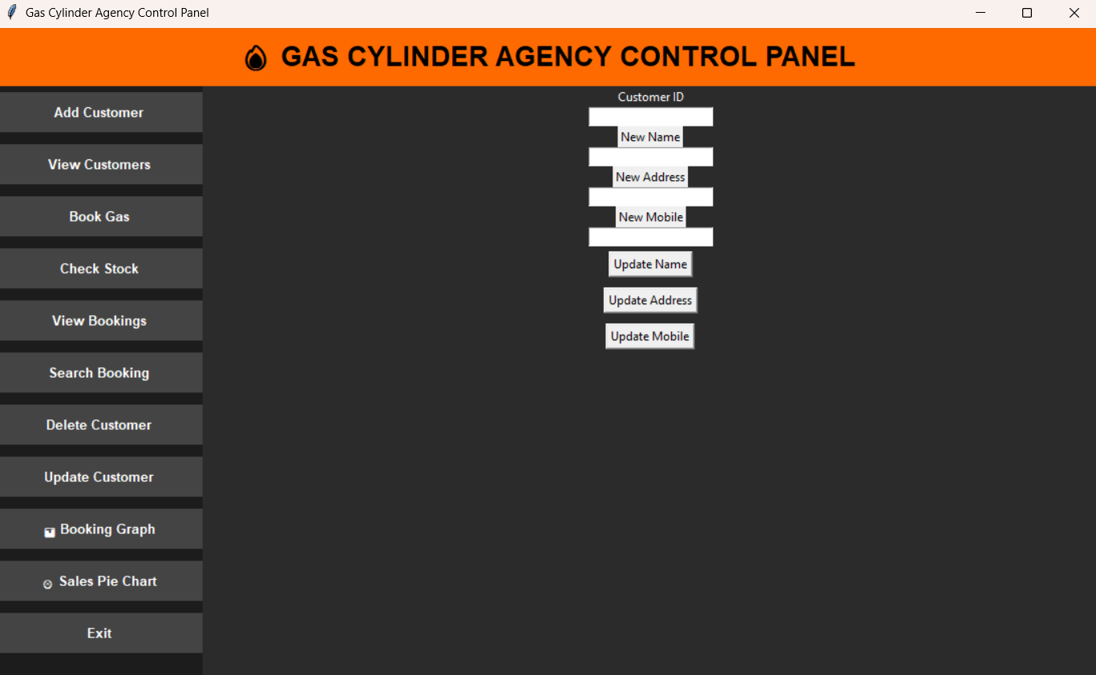

    - Booking Graph
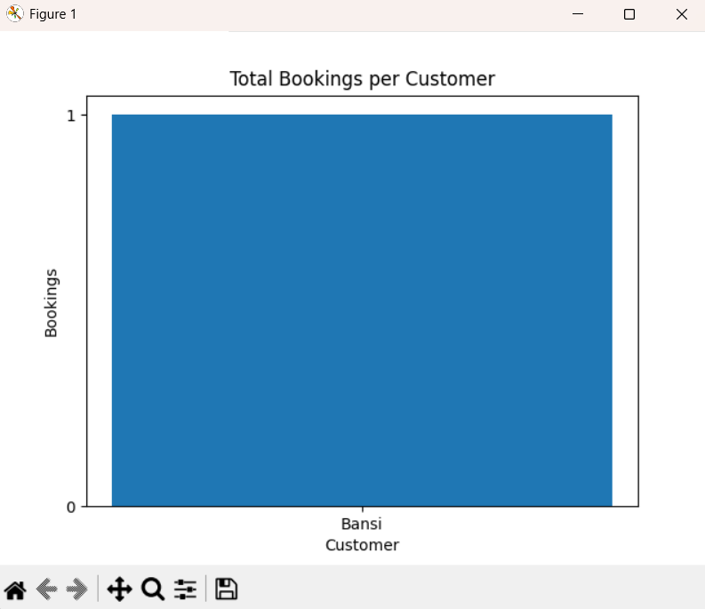

    - Sales Pie Chart
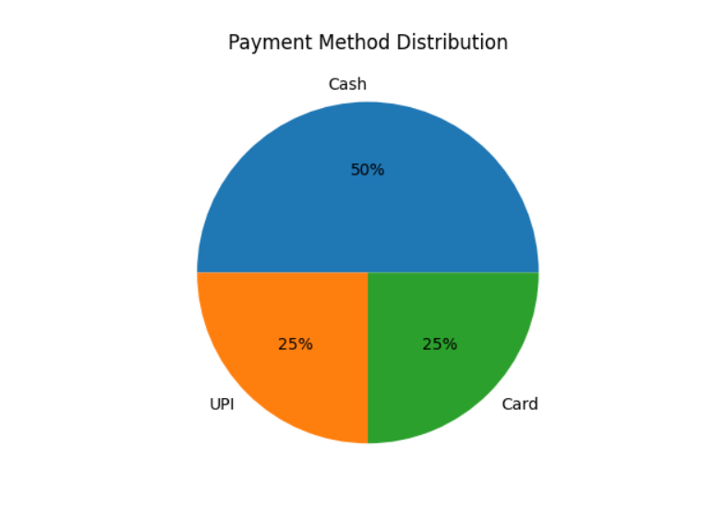

4. CONCLUSION
The Gas Cylinder Agency Control Panel project successfully demonstrates a real-world application using Python.
It simplifies the process of managing bookings, customers, and stock while reducing manual effort.
The system is:
- User-friendly
- Efficient
- Time-saving

5. LEARNING DURING PROJECT WORK
During the development of this project, I learned:
- GUI development using Tkinter
- File handling using JSON
- Data visualization using Matplotlib
- Input validation and error handling
- Developing real-world applications

6. BIBLIOGRAPHY

6.1 Online References
- Official Python Documentation – https://docs.python.org/3/
- Tkinter Documentation – https://docs.python.org/3/library/tkinter.html
- Matplotlib Documentation – https://matplotlib.org/stable/contents.html
- W3Schools Python Tutorial – https://www.w3schools.com/python/
- GeeksforGeeks (Python GUI & JSON concepts) – https://www.geeksforgeeks.org/
- Stack Overflow (Error solving & logic building) – https://stackoverflow.com/

6.2 Offline References

• College Notes on Python Programming
• Classroom Lectures and Practical Sessions
• Guidance from Faculty/Instructor
• Reference Books:
- Programming in Python by Reema Thareja
- Core Python Programming by Dr. R. Nageswara Rao

FIGURE INDEX

Sr. No. | Figure No. | Particulars
1 | Fig 1.1 | System Flowchart
2 | Fig 1.2 | Level 0 DFD (Context Diagram)
3 | Fig 1.3 | Level 1 DFD
4 | Fig 1.4 | GUI Main Dashboard
5 | Fig 1.5 | Add Customer Screen
6 | Fig 1.6 | Booking Gas Interface
7 | Fig 1.7 | Customer List Display
8 | Fig 1.8 | Booking Graph (Bar Chart)
9 | Fig 1.9 | Sales Pie Chart

TABLE INDEX

Sr. No. | Table No. | Particulars
1 | Table 1.1 | Customer Data Structure
2 | Table 1.2 | Booking Details Structure
3 | Table 1.3 | Stock Management Details
4 | Table 1.4 | Input Validation Rules
5 | Table 1.5 | Price & GST Calculation
6 | Table 1.6 | Sample Booking Records
7 | Table 1.7 | Output Receipt Format

